CS-210

Aiden Villanueva

Dec. 14, 2024

Design Document - Project Three

Item Tracking Program is designed to track and analyze the frequency of grocery items listed in a text file for the company Corner Grocer. Users can interact with the program to view the frequency of specific items, display all items and their frequencies, or generate a histogram of item frequencies. Additionally, the program ensures data persistence by creating a backup file.

Key Components

1. File Handling:

Reads data from a predefined input file (CS210_Project_Three_Input_File.txt).

Ensures error handling by prompting for a valid filename if the file cannot be opened.

Writes item frequency data to a backup file (frequency.dat).

Prompts the user for a valid filename if the backup file cannot be created.

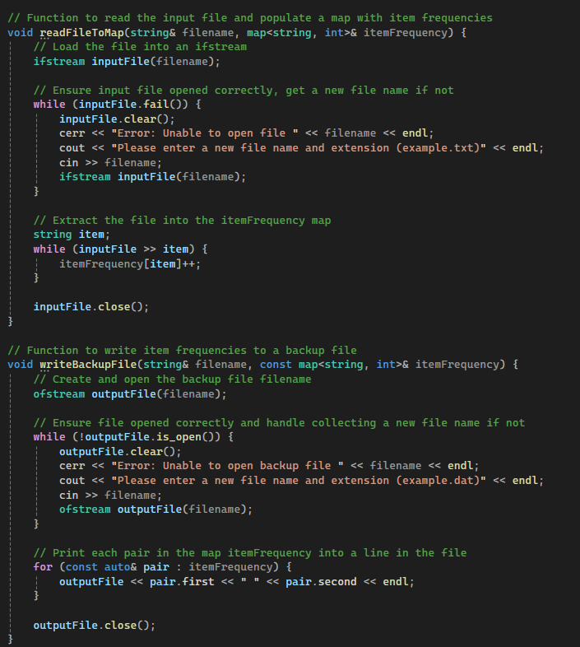

2. Data Storage:

Uses a map<string, int> to store item names as keys and their counts as values.

This structure allows efficient data insertion, retrieval, and iteration.

3. User Interface:

Provides a user-friendly menu with clear, unique options.

4. Core Functionalities:

Read File and Populate Map. Search Item Frequency. Display All Frequencies. Histogram Display.

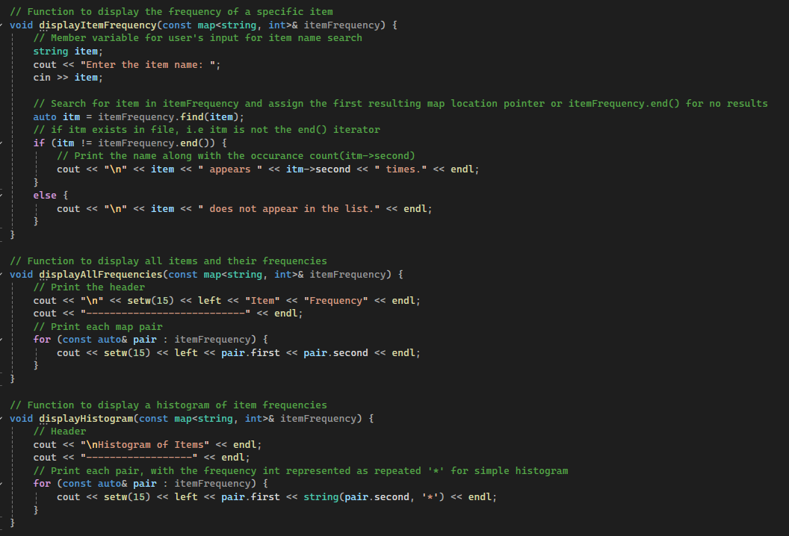

5. Data Validation and Error Handling:

Ensures input files are valid and prompts for corrections when necessary.

Validates user input to prevent crashes and ensures menu selections are within the expected range.

